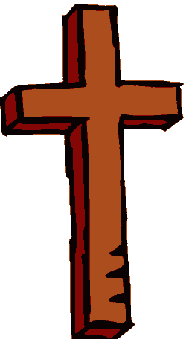
Christianity
Christianity is based of the teachings of Jesus Christ, a Jew who lived about 2000 years ago in what we now call Israel. Jesus taught his followers to "Do unto others as you would have them do unto you."

The followers of Jesus called him Christ. Christ is a Greek word that means, “chosen one.” They believed he was the son of God. In time followers of Jesus became known as Christians. Early Christians taught that the sins of the people would be forgiven if they became Christian.

Some years after Jesus died, Christians combined the stories of the life and wisdom of Jesus into four books known as the Gospels. Gospel means “good news.” The holy book of Christianity is known as the Bible and has two parts. The Old Testament consists of the sacred writings of the Jewish people, and was written mostly in Hebrew long before Jesus. The New Testament of the Bible includes the Gospels, along with letters by Christian writers. The Bible has been translated into more than 1,500 languages and has been read by more people than any other book.

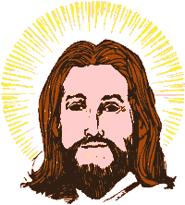
Almost two billion Christians live on every continent. They comprise the majority of people living in the United States and Canada (86%), Latin America (92%), Europe (76%) and Australia (85%). Christianity is also the most prevalent faith in Africa (48%). Christianity is a dominant force on every continent but Asia (9%). Most of the world’s population is in Asia, so only one-third of the world's population is Christian.

Christianity is divided into many sects. About half of the world’s Christian population is Roman Catholic. Pope John Paul II is the leader of the Roman Catholic Church. Catholic is a Latin word that means “universal,” and at one time it was the faith of almost all Christians. Roman refers to the fact that the Pope has lived in Rome for over five hundred years. Most Christians in Eastern Europe belong to Eastern Orthodox Churches. The Orthodox churches split with the Roman church in the Middle Ages. Many European leaders, including Martin Luther and John Calvin, protested against the Pope in a period known as the Reformation. The churches they started became known as Protestant sects. Major Protestant sects in America today are the Baptists (34 million), Methodists (13 million), Lutherans (8 million), Presbyterians (4 million), Episcopalians (2.5 million), and Pentecostals (2.4 million).

Christians worship in churches led by ministers and priests. Most Christians practice acts of religious significance called sacraments. The sacraments include baptism, when a Christian joins the church; confirmation, when a Christian confirms his or her faith; and matrimony. The Eucharist is the holiest of Christian sacraments in many Christian churches. During the service, members of a church will eat a small wafer of bread. Christian tradition states that at the Last Supper before his execution, Jesus asked his followers to think of the meal as the body and blood he would soon sacrifice.
Christian holy days include Christmas (the birth of Jesus), Easter (when Christians believe Jesus rose from the dead and ascended to heaven), and Lent, a forty-day holy period of penitence and self-denial.

Christianity
Christians believe that Jesus Christ was both a man and the son of God. They believe God sent Jesus as a messiah, or messenger. The Roman governor of Palestine executed Jesus by nailing him to a cross. Today the cross is Christianity's most important icon. Most Christians have crosses in and on top of their churches. Some Christians wear a cross as a necklace. The cross symbolizes a Christian's connection with Jesus.

